**RayStation Plans to MOSAIQ Process**

**RayStation**

* Under Plan Optimization, update dose statistics if necessary.
* Under Plan Design, ensure that beam names and numbers, isocenter name, and plan name are unique among all tx’s. (You can see previous treatments’ beam names in D and I in MOSAIQ.)

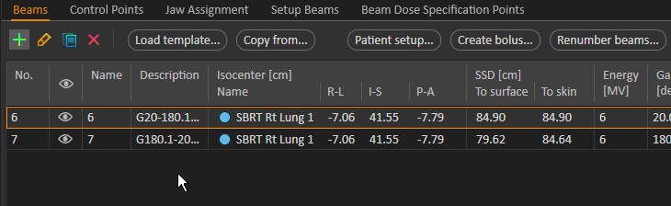

If you need to renumber beams, you’ll have to unapproved the plan and have the doctor reapprove it before you export to Mobius (later step).

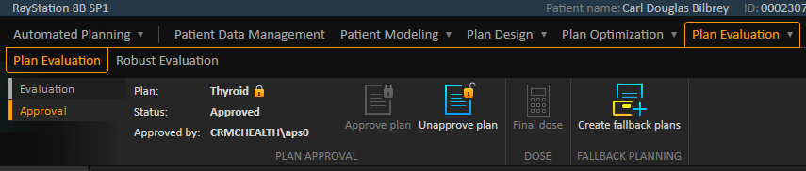

* If this is a prone case, under Plan Design, change the setup beam names to include *PA*.

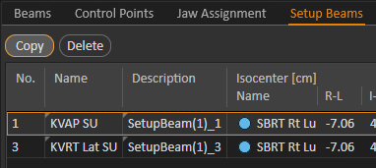

* Note Rx in top right corner.

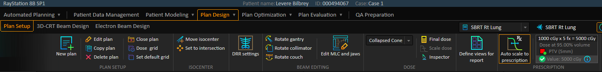

* Under Plan Optimization, check the DVH and Clinical Goals.
* Run script ExcludeFromMOSAIQExport. Under *ROI/POI details*, make any necessary changes. Make visible all ROIs that are not excluded from export, and make invisible all ROIs that are. Save the patient!
* Create report. The default template (ReportTemplateV8B_050619) is fine. Name the report *<plan name>, <m-d-Y>* and save it in Z:\TreatmentPlans.

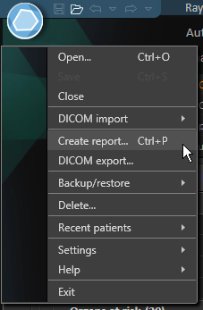

* Go to *ROI/POI details*.

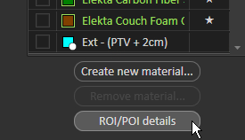

* Uncheck *DRR Contours* and check any contours that you want to send onto the DRRs. These are the same structures that you made visible on the DVH in a previous step.
* Export to IMPAC. (Check field and DRR boxes.)

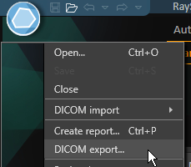

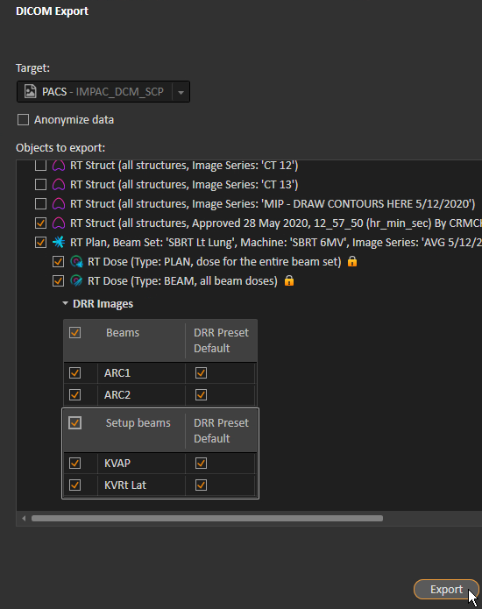

* In *ROI/POI Details*, check the structures that you do not want to export to Mobius. Use the table below to determine what to export. Then save the patient!

|  |  |
| --- | --- |
| **Plan** | **ROIs to Export** |
| Lung | * Targets * Carina * Elekta Carbon Fiber Shell * Elekta Couch Foam Core * Esophagus * External * Heart * Lungs (e.g., Lung_L, Lung_R) * SpinalCord * Other important organs near the target |

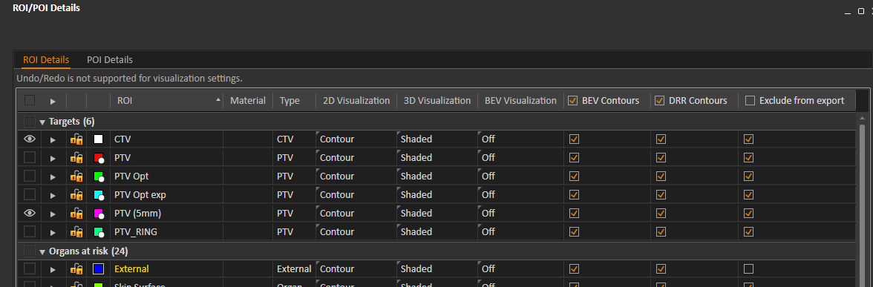

* Export to Mobius. (Do not check field and DRR boxes.)

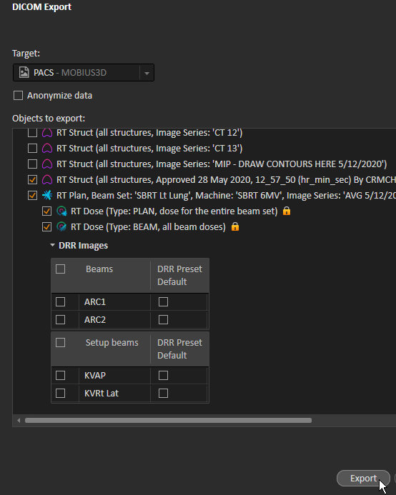

* In MOSAIQ, note start date and tx machine. In RS, note isodose.

**MOSAIQ**

* In *D and I*, make sure the pt has an Rx for the latest Dx. If they do not, select the Dx and click *Care Plan*. Use the appropriate *Course* number and ignore the other fields. Click *OK*.

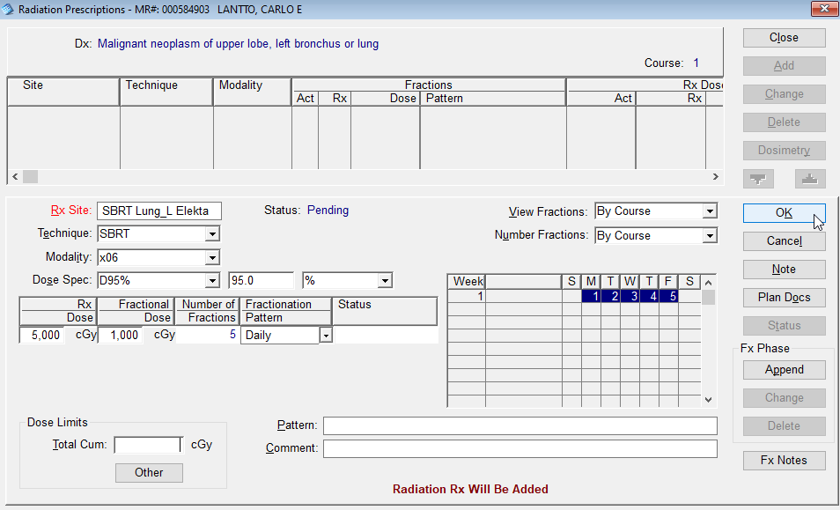

If the pt does already have a care plan and prescription, simply make sure the plan name matches the RS plan name. Click *Change* and change *Rx Site* field.





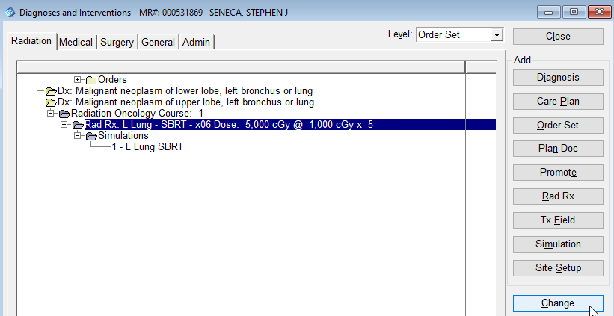

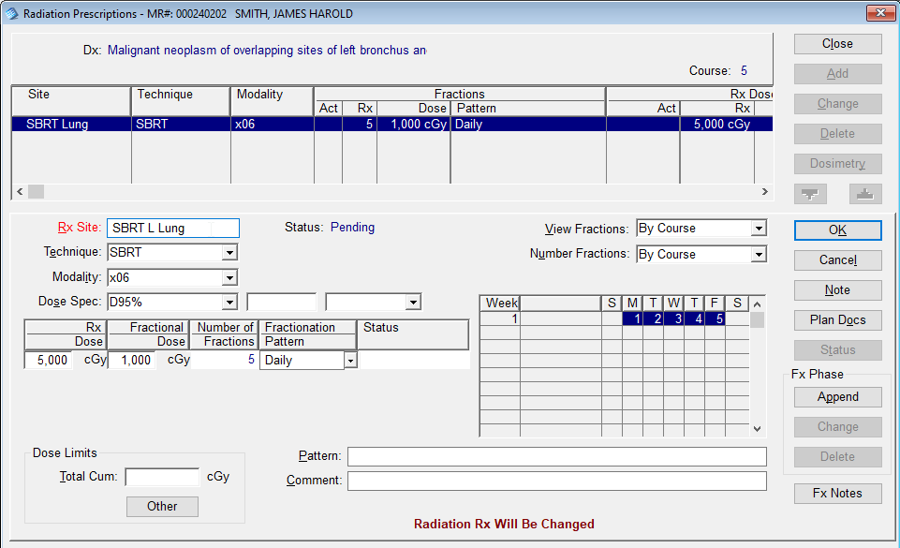

* Hit *File* > *Import/Export* > *RTP Import…*

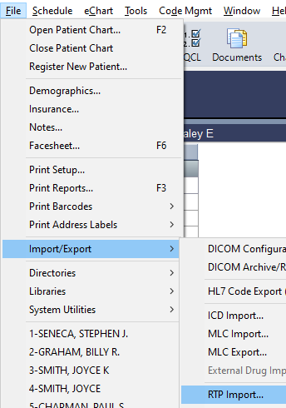

* Select the appropriate RTP data.

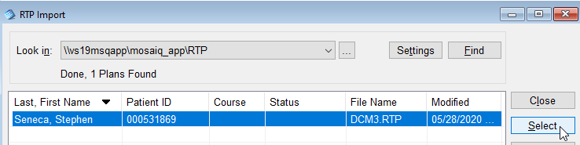

* Double-click *Site Setup*.

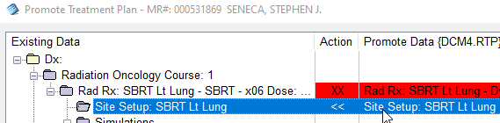

Click in the row for *Tolerance Table ID*, and select *12-Site Setup*.

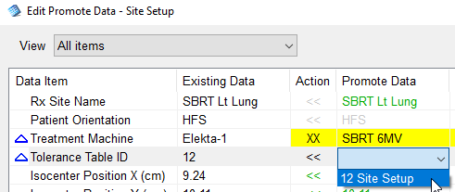

Change the tx machine, if necessary. Click *OK*.

* Click one of the tx fields. Click *Field Group*. Select plan Rx and tolerance is SBRT. If this does not work, you must change the tx machine and tolerance for each tx field (shown below).

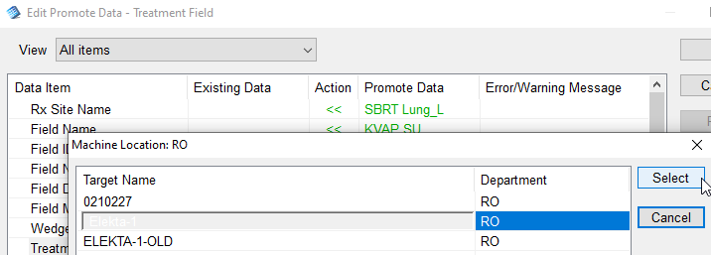

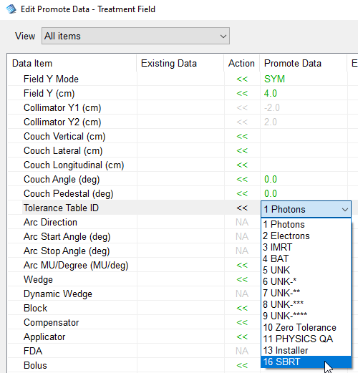

* Hit *Ignore* on the Course and Rx.
* The *Promote* button should no longer be grayed out. Click it. You will be asked if you want to delete the imported file. Say yes. Close the RTP Import window.
* Drag the Rx to the Course, if necessary.
* Double-click the CBCT beam in *D and I*. Change the type to CT and select the correct XVI preset. Click *<< Field Setup* and round the SSD to the nearest 0.5. Note this number.
* In D and I, click *Refresh*. Double-click the sim in *D and I* for the current course. Click *Field Note*.Add the rounded SSD from the previous step to the setup notes. If there are no setup notes:
  + For SBRT, use “See SBRT setup sheet.”
  + For non-SBRT, contact Shane.

In RayStation, under Plan Design > Plan Setup, click *Patient setup…*

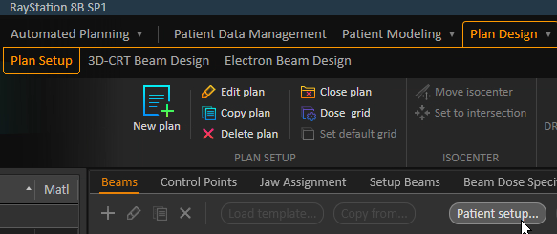

If there are couch shifts (there are none in the below photo), add them to the setup notes in MOSAIQ.

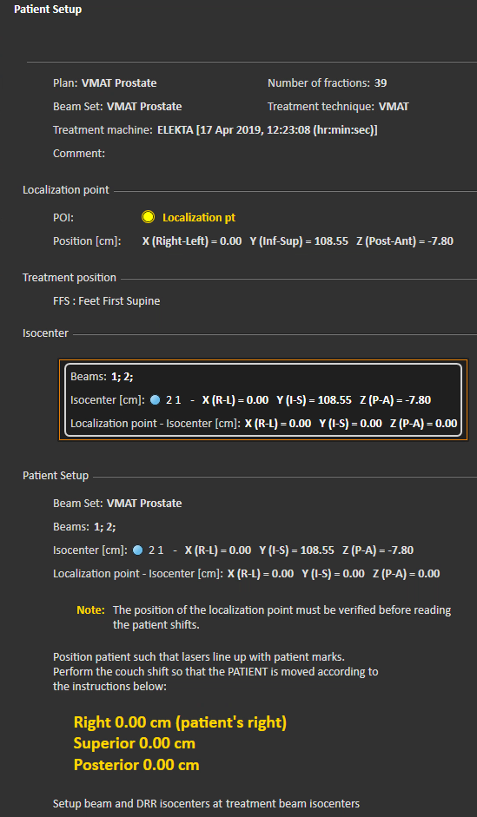

Copy the setup notes.

* In *D and I*, double-click *Site Setup* under the current course. Go to the *Volume Reference Data* tab and wait for images to load. Go to the *Setup* tab and paste setup notes under *Setup Instructions*. Verify correct machine. Verify that *Verification* is *Verify*. Click *Approve* and enter your credentials. Click *Refresh* in *D and I*.
* Go to *eChart* > *Images*. Verify that DRRs are associated with the correct fields.
* Double-click on each image in the list and adjust the window/level for unconventional fields. Check *Use for Tx Definition*.

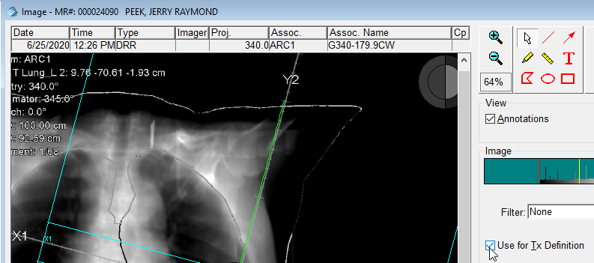

* In *D and I*, with the current course selected, click *Plan Doc*.

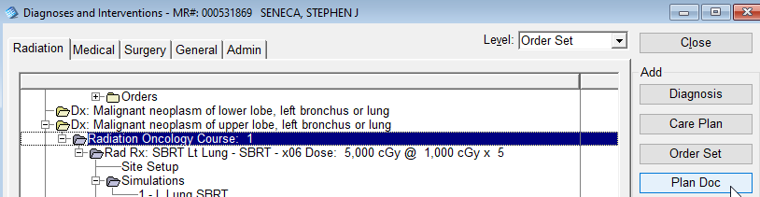

Open eScan/TreatmentPlans. Select the plan document, right-click, and select *Add*.

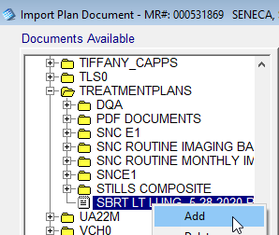

Click *Import*.

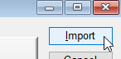

Adjust the *Plan Label* if necessary. For example, remove the *.PDF* extension.

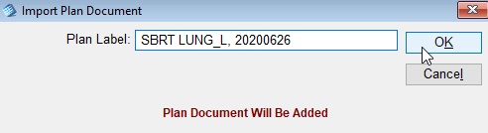

* In *D and I*, double-click plan document.



Select the Rx in the *Associations* field.

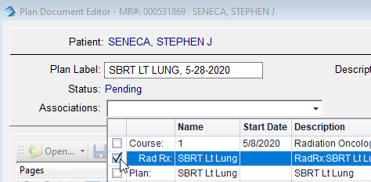

The plan should be moved to the *Plans* folder under the current course in *D and I*.

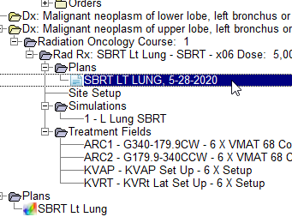

* In *D and I*, double-click each beam.

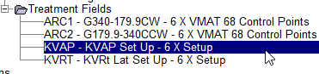

Change machine, if needed.

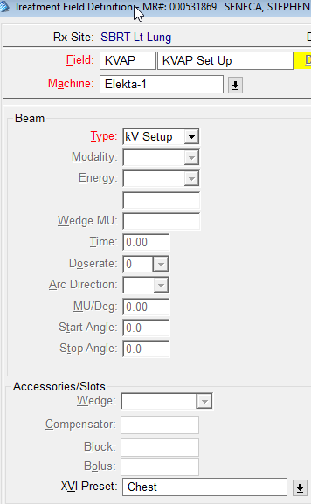

For VMAT beams, change *Doserate* to zero.

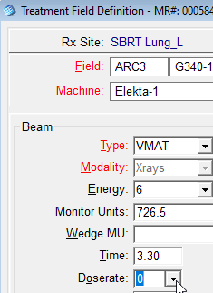

Click *<< Field Setup*.

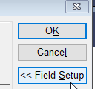

Round number in *SSD* field to the nearest 0.5 and paste setup notes into *Field Setup*.

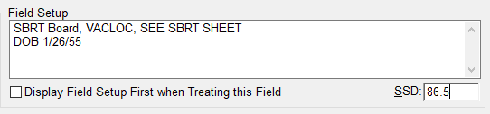

After clicking *OK*, you will have to click *Accept*.

If MD selected other isodose than 100% on plan, then doses/fields need to be adjusted:

In RS, go to *Plan Design* > *3D-CRT Beam Design* > Beam weighting- Dose weight %

-Daily dose x Dose weight % / field and enter into each field

* Go to *RO Treat* > *Tx Calendar*. Select the current course and plan. Select the start date. Click *Insert Sessions for Course* <*number>*. Click *Schedule All Fields*. Add the fields to the schedule in the following order: CBCT, setup beams (in order listed), << AFS Group >>, tx beams (in order listed). Click *OK* and *Schedule Fields*. If the daily doses for all tx fields do not sum to the total daily dose:
  + For each tx field, divide the Dly dose by the cumulative dose, and multiply the result by the field’s Dose. Round the result to the nearest whole number and enter it as the new dose for the field (in D and I).

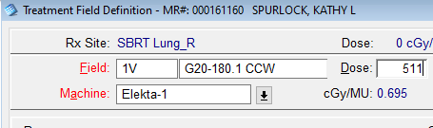

Ensure that there is no longer any red in the tx calendar.

* In *D and I*, click *Dosimetry*.

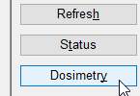

Verify MU and dose match plan.

* In *Dosimetry*,create Dose Tracking Site columns (Total Lung, Cord Dmax, etc.), as needed. Non-SBRT VMAT plans do not require any dose tracking sites.
  + Cord Dmax (for all lung plans):
    - In Plan Optimization > Plan Optimization, click Beam Dose icon in the top right.

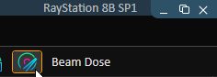

For each beam, use the DVH to find **approximate** Cord Dmax.

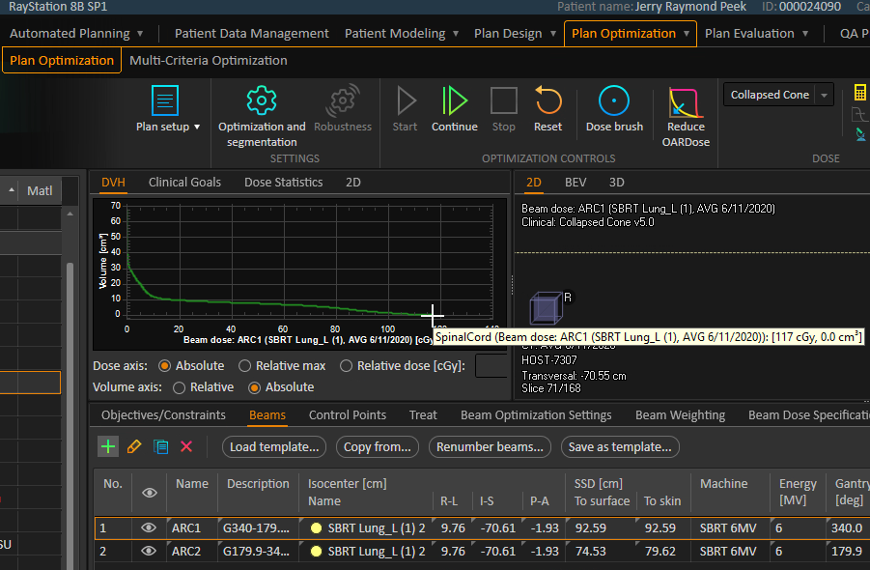

Obtain the Rx dose for that beam under *Beam Dose Specification Points*.

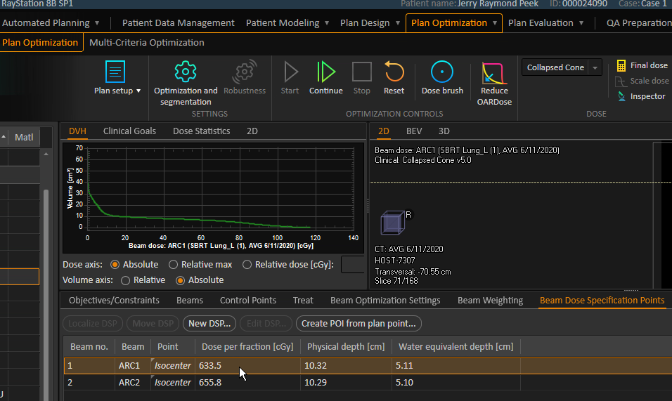

Divide the dose to site by the Rx dose for that beam. Round to three decimal places.

Example: 117 / 633.5 = 0.185

* + - In *Dosimetry* in *D and I*, click *Add* under *Dose Site*.

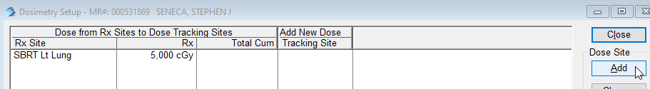

* + - Enter *Cord Dmax* as the site name. Leave the prior dose blank.

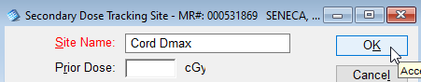

Double-click under the new dose site calc for each tx beam. Add the result from above.

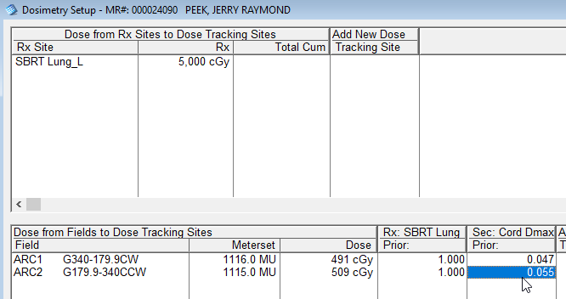

* + Double check the tx calendar for the dose site changes.



* Create Dose Action Points for upcoming boosts, dose changes, etc.

Cord dose calc:

Total cord dose = X X (whole #) = Coefficient

# of fracs Daily dose for dose column

**Mobius**

* Review and tag structures appropriately.
  + Select the pt from the list on the left. Click the gear icon for the desired plan.

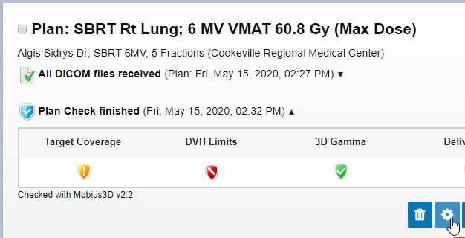

* + Under “ROI Identification”, change the ROI types as necessary.

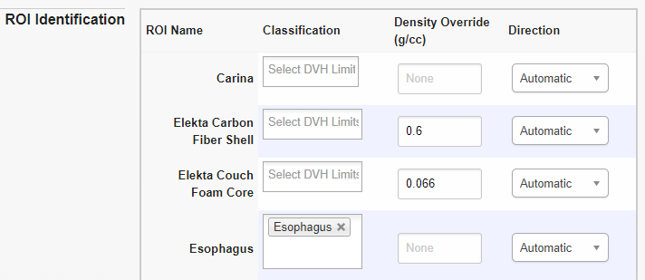

Click *Recompute Plan Check*.

* Edit DVH.
  + Click *View Plan Check*.

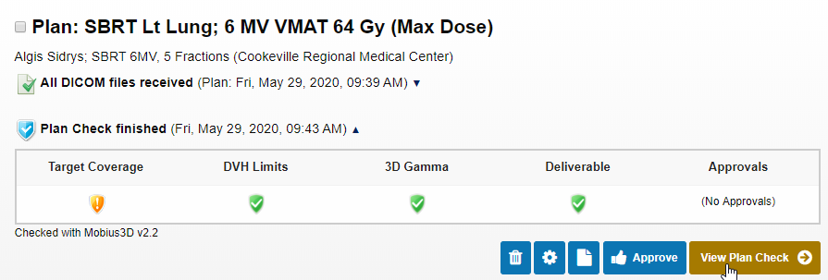

* + Ensure that only the desired structures are visible on the DVH.

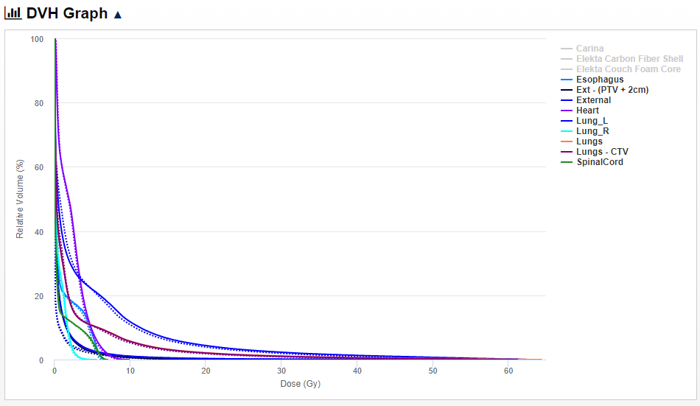

* Approve the plan check.
  + Check *Acknowledge Alerts*. Click *Yes*.

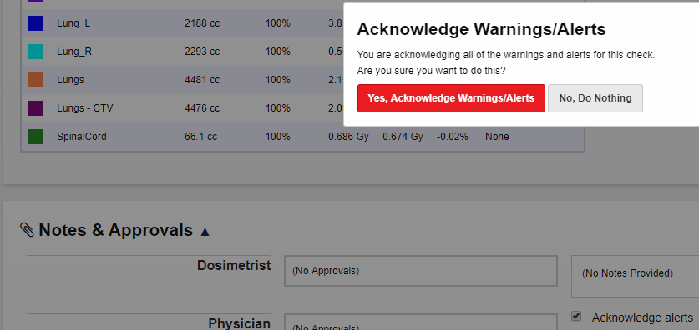

* + Click *Save Notes*.



* + Click *Approve This Plan*.



* Wait a minute or so for the PDF to refresh; then print the PDF.
  + Ensure that Target Coverage is either green or gray, and that your name is under *Approvals* for the appropriate plan check.
  + Click PDF icon.

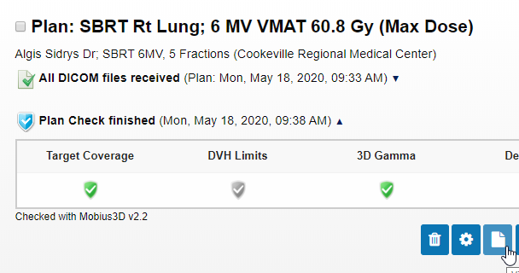

* + Ensure that PDF has the appropriate Notes and that your name is listed under “Approvals.”

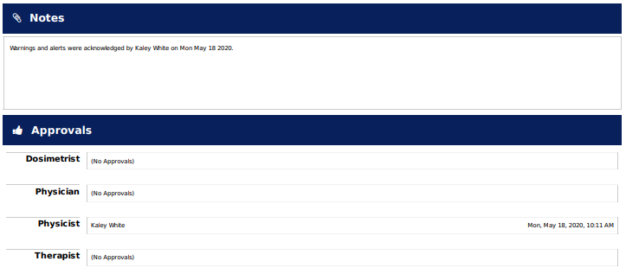

* + Save the PDF in Z:\TreatmentPlans. The default filename is fine.

**MOSAIQ**

* Add the Mobius document.
  + Go to *Chart*.

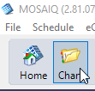

* + On the Documents tab, click *Add* and *eSCAN*.

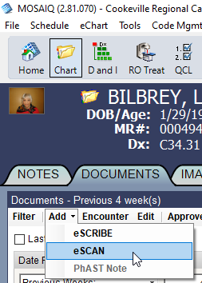

* + Navigate to Z:\TreatmentPlans, right-click the Mobius document, and click *Add*.

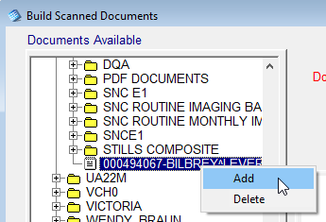

* + Change the document type to *D- Dose Calc* and the encounter date to the plan date (today). Set review required by the MD.

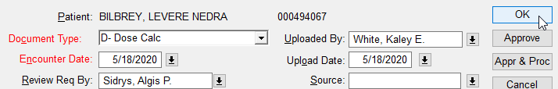

* Set the document’s status to *Review Req*.
  + Select the document and click *Status*.

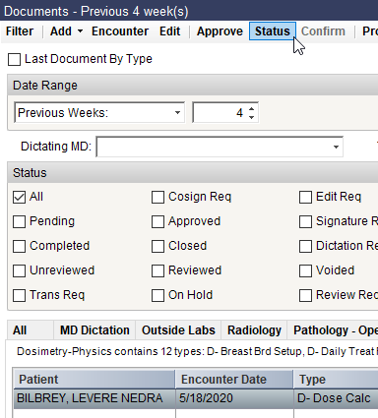

* + Select *Review Req*, enter your password, and click *OK*.

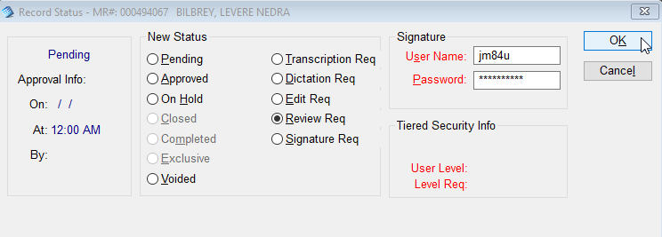

**MOSAIQ**

* Go to *Code Mgmt* > *Patient Code Summary*.

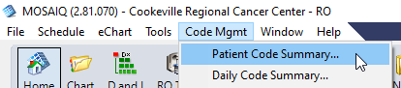

Refer to *Order Sets Needed in MOSAIQ Before Treatment* to determine the appropriate charges.

Repeat the following steps for each charge.

* + Click *Add*.

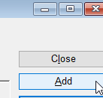

* + Select the charge under *Code*.

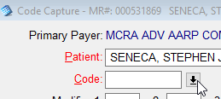

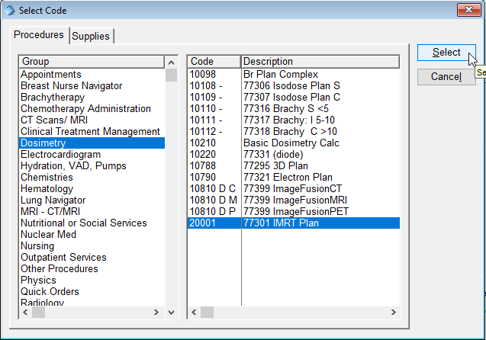

* In *D and I*, expand the *Orders* folder at the top.

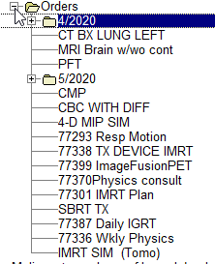

If the orders do not match the charges you entered (disregard the qty):

* If the MD is AS, fill out an order request form from dosimetry. Write *Dr. AS* and the date in the top right corner.

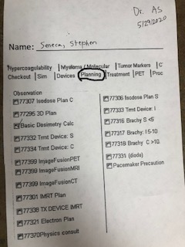

Deliver the form to AS’s desk.

* If the MD is DJ, send an MD Orders QCL with a descriptive comment.
* Send QCLs.
  + Go to *QCL*.

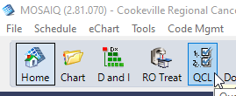

* + Click *Add*.

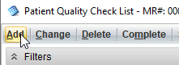

* + Check *Use Task Set* box.

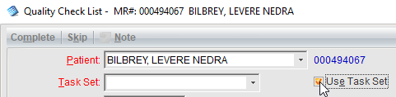

* + Click the down arrow beside *Task Set*.Select *New start- T, E?* and click *Select*.

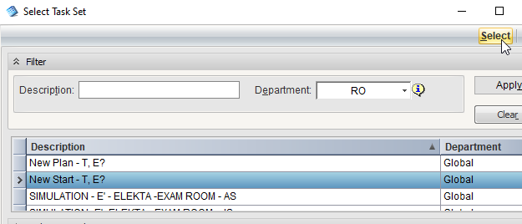

* + Click *Save*.

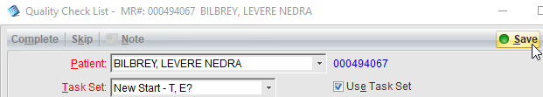

* + There should be three new fields, one each for Responsible: Jennifer Carter (Dr. AS NP), Physics, and blank. Double-click the blank one.

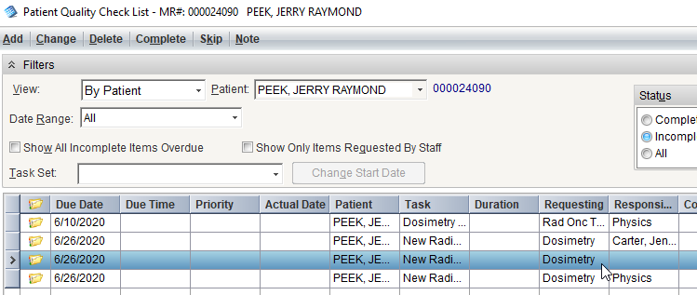

Change the due date to the tx start date and the responsible party to the tx machine. You can search the machine using the *Last Name / Location* field. Click *Select*.

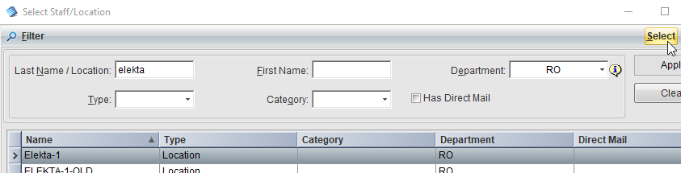

Click *Save*.

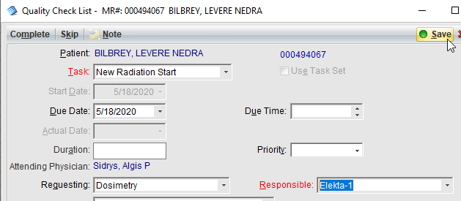

Double-click each of the three QCLs and add the following comment: *<machine> <plan> <MD initials> Starts <start date> @ <start time>*. Example: E1 SBRT Lung AS Starts 9/28/2020 @ 3:00pm

* Change appt notes.
  + Go to *Schedule* > *Patient*.

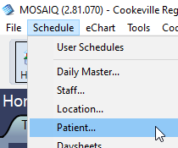

* + If the pt has no appointments, schedule them.
    - Click *Add*.
    - Select *Clinical Treatment Management* and the appropriate rad tx (e.g., *Daily SBRT tx Delive*).
    - Click *Select*.
    - Fill in the start date, duration (30” for SBRT, 15” otherwise), # of appts (# of fx’s), and location (machine).
    - Add the following comment: *\*\*\*DAILY IGRT*** <brief description of tx>; Dr. <MD initials>*. Example: *\*\*\*DAILY IGRT*** SBRT Lung Dr. DJ*.
    - Click *OK*.
  + Double-click first appt.

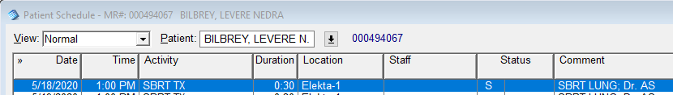

* + Add “New start” to the *Comments* field. Click *OK*.

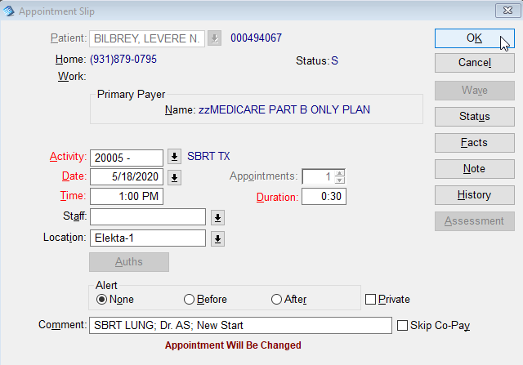

* + Verify last date of tx matches date in RO Treat calendar.

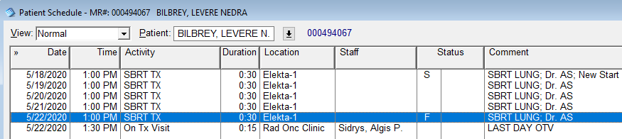

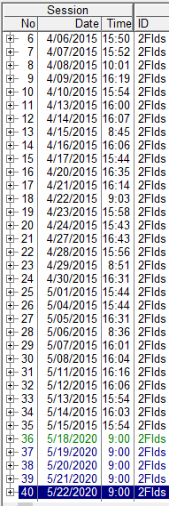

* + Add “Last tx - send QCLs” to the comments on the last tx.

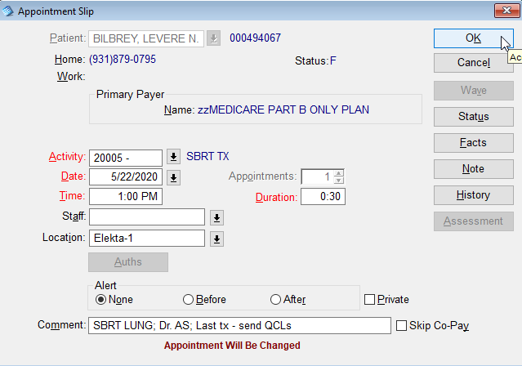

* + Add OTV (*Appointments* > *On Tx Visit*)on last day, if not in there for 15-30 mins after tx appt.
    - Example: OTV exists at 1:30, 30 min after tx at 1:00. Do not add OTV.

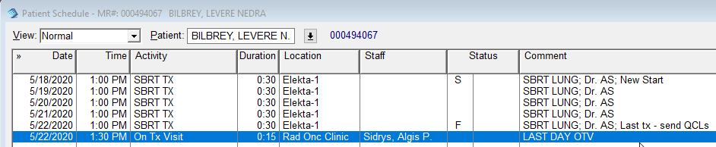

* Check for authorization for tx.
  + Go to *Home* and view the Quality Check List.

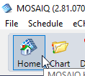

* + Expand *Authorizations*. If the pt’s authorization is pending, email Shane. (If the pt is not listed, they are not pending.)

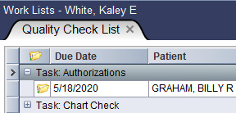

* Once pt is approved for tx, complete pt on our Dosimetry QCL and from Authorization list. Double click the QCL and click *Complete*.

